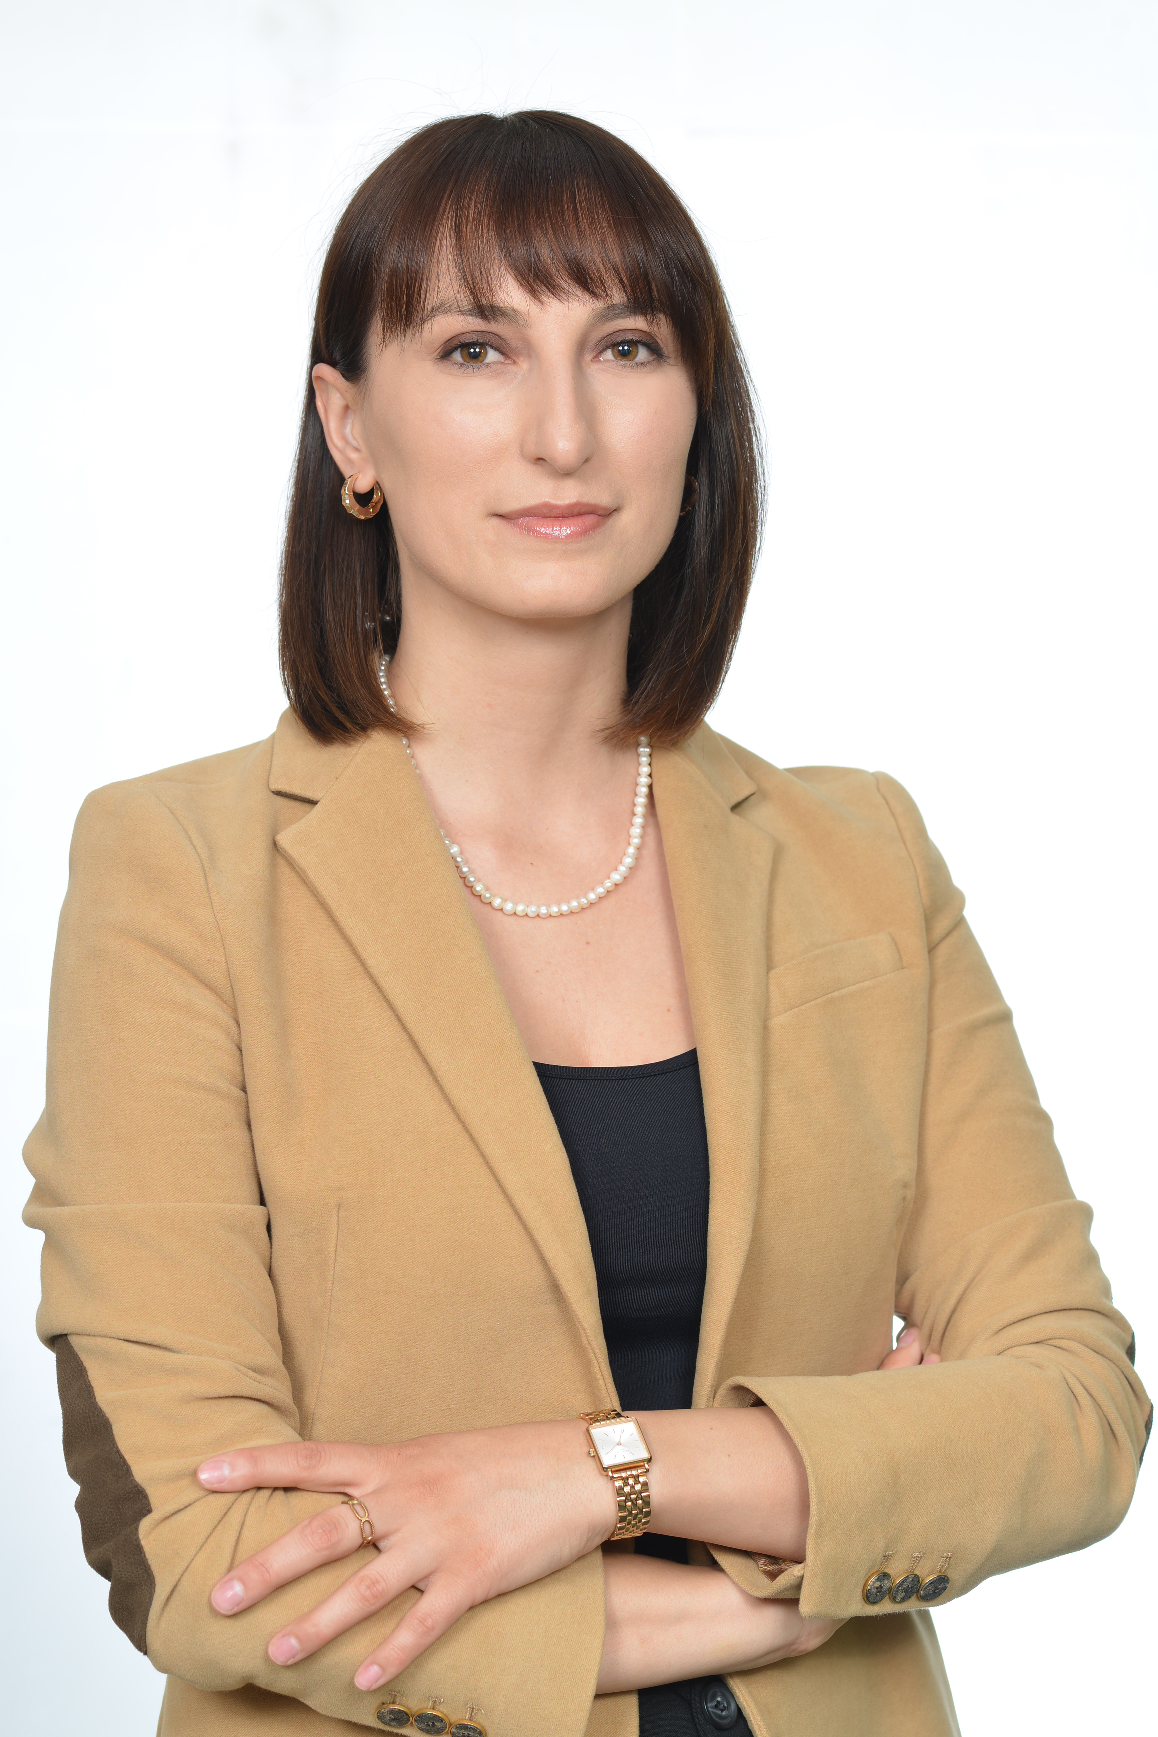

MSc. Liridona Dodaj

MSc Liridona Dodaj, after completing her Bachelor's and Master's studies in Mathematics at FSHMN, decided to embark on a path dedicated to teaching.
In October 2023, she joined the academic staff at UBT College as a Mathematics lecturer. With nine years of experience in the field of education, she has demonstrated exceptional ability in communicating mathematical knowledge.
In her role as a lecturer, she has been a leader in utilizing and advancing new methodologies to integrate technology into teaching.

ORCID: https://orcid.org/my-orcid?orcid=0000-0002-0523-2412
RESEARCH GATE: https://www.researchgate.net/profile/Dritero-Arifi
Email: liridona.dodaj@ubt-uni.net
Address: University for Business and Technology. Rexhep Krasniqi Nr. 56, 10.000 Prishtina, Kosovo

Publikimet tuaja me te fundit ne kohe

PUBLIKIMET SHKENCORE
Revistat Shkencore
Titulli i punimit | Emri i Revistës | Viti / Volumi / faqet
"Kosovo Society: Coexistence, Challenges and Opportunities. An Overview of Social Policy in Serbia and Kosovo" | Brill Publishing House | Vo  2022/Volume 210/pp 224-254
Institutional and non-institutional actors in policy-making processes: a case study | Journal of Governance and Regulation | 2023/ Volume 12/ Nr 2/ pp 147-155
The education situation of the Roma community in Kosovo | Emerald Publishing | 2023 / 1-15
Testing Okun's Law: Evidence from the Western Balkan Countries | SAGE OPEN | 2023/Volume 12/Nr 2/pp 147-155
Përmbledhje (abstrakte) nga Konfereca Shkencore Kombëtare dhe Ndërkombetare
Titulli i punimit | Emri i Revistës | Viti / Volumi / faqet
The Albanian national unification in the Balkans area in the context of Kosovo’s political party programs | Konferencë Ndërkombëtare  Kolegji UBT | 2108
Ethics code of NGOs in Kosovo | Konferencë Ndërkombëtare  Kolegji UBT | 2019
Public diplomacy and the case of Kosovo | Konferencë Ndërkombëtare  Kolegji UBT | 2020
The importance of public participation in building up democracies in former Yugoslav states. Case study: Kosovo and Croatia | Konferencë Ndërkombëtare  Kolegji UBT | 2020
The gap between the legal framework and social order in addressing property rights for Kosovo women | Konferencë Ndërkombëtare  Kolegji UBT | 2021
The level of student participation in decision-making processes in Kosovo Universities: a comparative study between the University of Prishtina and the University of Business and Technology | Konferencë Ndërkombëtare  Kolegji UBT | 2021
The trade war between the U.S. and China and its impact on the E.U. | Konferencë Ndërkombëtare  Kolegji UBT | 2022

