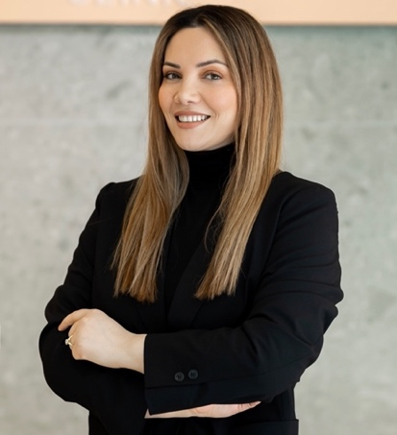

Lisjeta Thaqi Jashari

Lisjeta Thaqi Jashari embarked on her academic journey at the University of Prishtina, Hasan Prishtina, where she completed both her Bachelor's and Master's degrees. Her academic pursuits were driven by a passion for education and a desire to contribute meaningfully to the field.
With over 15 years of experience in the field of education, Lisjeta has cultivated a deep understanding of pedagogical approaches and educational methodologies. Her expertise spans various aspects of teaching and learning, with a particular focus on fostering inclusive and effective educational environments.
Currently, Lisjeta Thaqi Jashari is a Ph.D. candidate at the Faculty of Education, University of Ljubjana in Ljubljana, Slovenia, where she is delving into the intricacies of teaching, learning, and education. Her doctoral research is poised to make valuable contributions to the advancement of educational practices, aiming to address contemporary challenges and explore innovative solutions.

Publications

- 2019

Teachers’ perceptions of developing writing skills in the EFL classroom
Lisjeta Thaqi Jashari, Mateja Dagarin Fojkar
ELOPE: English Language Overseas Perspectives and Enquiries 16 (2), 77-90
https://journals.uni-lj.si/elope/article/view/8724
https://doi.org/10.4312/elope.16.2.77-90

Conferences

- 2014
Lisjeta Thaqi Jashari
Presenter: The impact of songs and films on the improvement of listening and speaking skills
Ketnet, Prishtina (Kosovo) 2014

- 2016
Lisjeta Thaqi Jashari
Presenter: The improvement of writing skills through online learning​
Ketnet, Prishtina (Kosovo) 2016

- 2019
Lisjeta Thaqi Jashari
Presenter: Teachers’ perceptions towards developing writing skills in EFL classroom
Language in Focus, Dubrovnik 2019

- 2020
Lisjeta Thaqi Jashari
Presenter: Differentiated instruction to improve writing skills in the English language
ECER, Glasgow 2020 (Cancelled due to Covid19)

- 2021
Lisjeta Thaqi Jashari
Presenter: The improvement of teaching practices through effective use of smart boards in “mileniumi i tretë” school.
Kosova International Conference on Educational Research
Prishtina (Kosovo) 2021

- 2021
Lisjeta Thaqi Jashari
Presenter: Differentiated instruction to improve writing skills in the English language
UBT 10th International Conference on Business, Technology and Innovation
UBT Innovation Camp, Pristina (Kosovo) 2021

