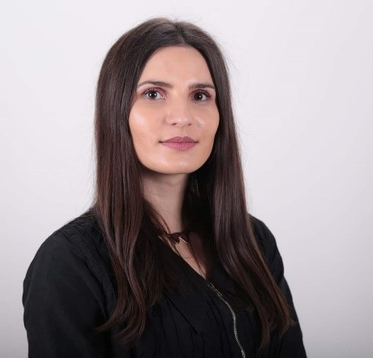

MsC Saranda Demolli

MSc. Saranda Demolli is Assistant and Coordinator of the Faculty of Mechatronics Engineering at UBT, Prishtina. She completed her master's degree in Mechatronics Management at UBT and has teaching experience, especially in mathematics and engineering subjects. Saranda also worked as an assistant in the office of Academic Affairs and human resources at UBT.

RESEARCH GATE: https://www.researchgate.net/profile/Saranda-Demolli
Email: saranda.demolli@ubt-uni.net
Address: University for Business and Technology, 10.000 Prishtina, Kosovo

Publikimet tuaja me te fundit ne kohe

Përmbledhje (abstrakte) nga Konfereca Shkencore Kombëtare dhe Ndërkombetare
Titulli i punimit | Emri i Revistës | Viti / Volumi / faqet
PID controller tunning of crane control system | International Conference on Business, Technology and Innovation UBT | 2019
Implementing a Low-Cost Energy Meter | International Conference on Business, Technology and Innovation UBT | 2019
Analysis of the photovoltaic solar energy capacity of PV system built in Gjakova (Kosovo) | International Conference on Business, Technology and Innovation UBT | 2019
The challenges of industrial automation in manufacturing companies in Kosovo | International Conference on Business, Technology and Innovation UBT | 2021
The impact of digital transformation on industrial automation | International Conference on Business, Technology and Innovation UBT | 2023

