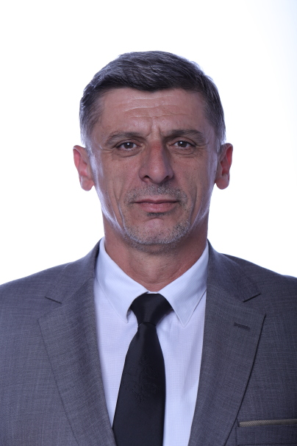

Dr. sc Nexhmi Krasniqi

Prof. Assoc. Nexhmi Krasniqi is a professor of the Faculty of Energy Engineering at UBT College in Pristina. He completed his initial studies at the University of Pristina, Faculty of Mining and Metallurgy in 1993, where he received the title "Graduate Mining Engineer". In 2007, he finished his master's studies at the University of Pristina, Faculty of Mining and Metallurgy and received the title "Master of Technical Sciences". In 2014, he completed his Doctoral studies at the Polytechnic University in Tirana, Faculty of Mining Geology, where he received the title of "Doctor of Technical Sciences", defending his Doctoral Thesis with the title: "Optimization of technical and economic parameters for the surface exploitation of coal in Kosovo. The field of study of Dr. Sc. Nexhmi Krasniqi is Mining Economics. He currently works as a professor in the Bachelor and Master programs at UBT College within the Department of Energy Engineering and Mechatronics Engineering.

ORCID: https://orcid.org/0000-0002-3585-8328
RESEARCH GATE: https://www.researchgate.net/profile/Nexhmi Krasniqi
Email: nexhmi.krasniqi@ubt-uni.net
Address: University for Business and Technology. Rexhep Krasniqi Nr. 56, 10.000 Prishtina, Kosovo

PUBLIKIMET SHKENCORE
REVISTAT SHKENCORE
Titulli i punimit | Emri i Revistës | Viti / Volumi / faqet
Protection Coordination in a Wind Power Plant Integrated with the Kosovo Power System | Ecological Engineering & Environmental Technology | Volume 24, Issue 8, 2023, pp.64-72.
KONFERECAT SHKENCORE NDËRKOMBETARE
Titulli i punimit | Emri i Revistës | Viti / Volumi / faqet
Impact of the Wind Power Plant Connection to the Kosovo Power System | Elsevier, Science Direct, IFAC-Papers On-Line | Volume 55, Issue 39, 2022, pp. 393-398.
Electricity production from solar Energy in Kosovo and Environmental Impacts | Elsevier, Science Direct, IFAC-Papers On-Line | Volume 55, Issue 39, 2022, pp. 302-307.
Network analysis for voltage regulation in Substation 35/10 [kV] “Malisheva” | Elsevier, Science Direct, IFAC-Papers On-Line | Volume 55, Issue 39, 2022, pp. 296-301.
The role of smart grid in the management of the distribution system | National Committee CIGRE Kosovo NC CIGRE Kosovo, 2nd Conference | November, 2023
Electricity production in Kosovo and its impacts on the environment | National Committee CIGRE Kosovo NC CIGRE Kosovo, 2nd Conference | November, 2023
Main Tests of Power Transformer TR2 in the Substation 35/10 kV "Xerxe" | UBT Knowledge Centre, IC-EEE 2022, UBT International Conference | October, 2022
SCADA system in control and automation of distribution system | UBT Knowledge Centre, IC-EEE 2022, UBT International Conference | October, 2022
Component dimensioning for a combined photovoltaic and heat pump system installed in a residential building | UBT Knowledge Centre, IC-EEE 2022, UBT International Conference | October, 2022
Integration of Photovoltaic Energy in the Electricity System of Kosovo | UBT Knowledge Centre, IC-EEE 2022, UBT International Conference | October, 2022
Testing of the Oil Type Distribution Transformers | UBT Knowledge Centre, IC-EEE 2021, UBT International Conference | October, 2022
Study Aspects for the Solar-Photovoltaic System with Installation Capacity of 60.3 kWp | UBT Knowledge Centre, IC-EEE 2021, UBT International Conference | October, 2022
Connection of new wind power plant to the electrical power system of Kosovo. | UBT Knowledge Centre, IC-EEE 2019, UBT International Conference | October, 2021
The Function of Generating Work and the Form of Connection of Wind Turbines to Each Other in Different Geographical Positions | UBT Knowledge Centre, IC-EEE 2021, UBT International Conferenc | October, 2020
Environmental pollution from industrial waste. A case study of Kosovo | UBT Knowledge Centre, IC-EEE 2021, UBT International Conferenc | October, 2020

